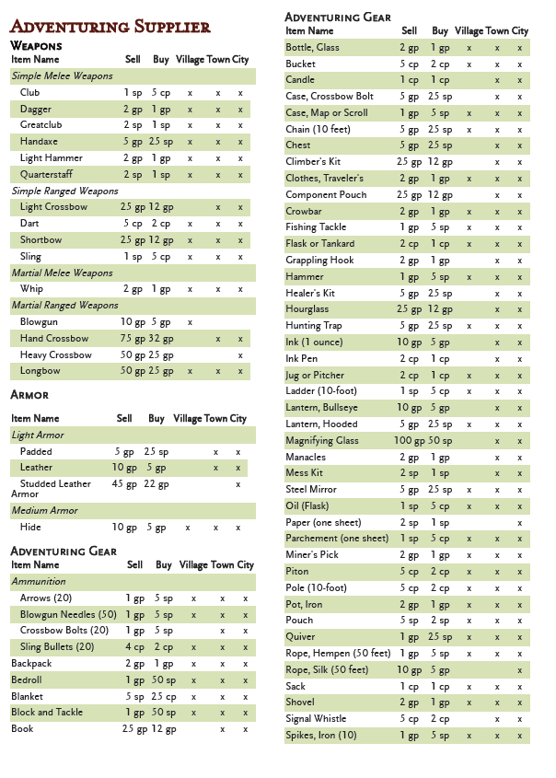

**The Salty Seagull**

Extras:

Extra potions:

Hawkeye Kohl (100gp)

|  |
| --- |
| *Potion, uncommon*  When applied around the eyes, this black powdery makeup allows the wearer to shoot ranged weapons they are proficient with up to their maximum range without disadvantage for 8 hours or until removed. In addition, the user gains advantage on Perception(Wis) checks involving sight. Hawkeye Kohl is especially valued in sunny regions due to its light absorbing property, which conversely can prove a detriment in poorly lit conditions. You cannot see in dim light while using Hawkeye Kohl.  Hawkeye Kohl is typically found in a small earthen pot with 1d4 applications within. |

Potion of Goose (150gp)

|  |
| --- |
| *Potion, uncommon*  This white potion, often bottled in a clear bottle adorned with a partly chipped off duck, when consumed, it is tangy and sour, and turns the user into a 1' goose. You speak in honks, therefore, no one understands you. You gain 1d4 bonus to [Dexterity](https://www.dandwiki.com/wiki/5e_SRD:Dexterity) ([Stealth](https://www.dandwiki.com/wiki/5e_SRD:Stealth_Skill)) and [Charisma](https://www.dandwiki.com/wiki/5e_SRD:Charisma) ([Intimidation](https://www.dandwiki.com/wiki/5e_SRD:Intimidation_Skill)) checks as you find that as a goose, it is easier to hide and intimidate others. The potion's effect lasts 1 minute from when the transformation takes place. |

Potion of Divination (300gp)

|  |
| --- |
| *Potion, rare*  For 1 hour after you drink this potion, you are immune to the surprised condition. Additionally, once within that same hour, you can use your action to make a prediction about what lies briefly ahead. Choose a room you can see but haven't entered yet, a spherical area with a 30 foot diameter within 100 feet of you while outside, or the room or area you are currently in. You can make one of the following predictions about the location of your choice:  **Predict Encounter**  You can tell if the chosen location contains creatures. If there are creatures, you know where they are in the location, and the basics of what they are doing (Hiding, talking, fiddling with an object, etc. You don't learn any more precise information than that, like what a creature is saying for example.). If you tell other creatures this knowledge, they can't be surprised by the creatures either.  **Predict Integrity**  You can tell if the chosen location contains an environmental or structural hazard that wasn't put into the location on purpose. If there is one, you can tell how to avoid it (But not where it is).  **Predict Trap**  You can tell if the chosen location contains any traps. If there is one, you learn where the trigger mechanism for it is (But not what it is), if any. |

